**VISVESVARAYA TECHNOLOGICAL UNIVERSITY, BELGAUM 59014**



Website DevelopmentReport on

“*ONLINE QUIZ*”

BY

SIDHARTH S NAIK (1BM13CS102) SIDDHARTH DIAS (1BM13CS101)

SRIKANTHA AM (1BM13CS108)  SREEPRANEETH K (1BM13CS107)

Under the Guidance of

SARITHA A N

Assistant Professor, Department of CSE

BMS College of Engineering

Website Development carried out at



Department of Computer Science and Engineering

BMS College of Engineering

(Autonomous college under VTU)

P.O. Box No.: 1908, Bull Temple Road, Bangalore-560 019

2015-2016

**BMS College of EngineerinG**

**DEPARTMENT OF COMPUTER SCIENCE AND ENGINEERING**



***CERTIFICATE***

This is to certify that the website development titled “Online Quiz” has been carried out by SIDDHARTH DIAS (1BM13CS101), SIDHARTH S NAIK(1BM13CS102), SRIKANTHA AM (1BM13CS108) and SREEPRANEETH K (1BM13CS107) during the academic year 2015-2016.

Signature of the guide Signature of the HOD

**SARITHA A N Dr. H. S. GURUPRASAD**

Assistant Professor Head of Department

Department of C.S.E Department of C.S.E

BMSCE, Bangalore. BMSCE, Bangalore.

**BMS College of EngineerinG**

**DEPARTMENT OF COMPUTER SCIENCE AND ENGINEERING**



***DECALARATION***

We, SIDDHARTH DIAS(1BM13CS101), SIDHARTH S NAIK(1BM13CS102), SRIKANTHA AM(1BM13CS108) and SREEPRANEETH K(1BM13CS107)

students of 6th Semester, B.E, Department of Computer Science and Engineering, BMS College of Engineering, Bangalore, hereby declare that, this website development work entitled "ONLINE QUIZ" has been carried out by us under the guidance of Ms. SARITHA A N, Assistant Professor, Department of CSE, BMS College of Engineering, Bangalore during the academic semester Jan-May 2016

We also declare that to the best of our knowledge and belief, the development reported here is not from part of any other report by any other students.

**Signatures**

SIDDHARTH DIAS (1BM13CS101) :

SIDHARTH S NAIK(1BM13CS102) :

SRIKANTHA AM (1BM13CS108) :

SREEPRANEETH K (1BM13CS107) :

**TABLE OF CONTENT**

Chapter Page No

1. INTRODUCTION
   1. Aim 5
   2. Scope 5
   3. Organization of report 5
2. Description of Project

2.1 Features 6

2.2 Technical Details 7

2.3 Hardware & Software Requirement 8

2.4 Screenshots

1. Conclusion & Future Enhancement 9
2. Bibliography

**Introduction**

**1.1 AIM:**

The aim of this project is to develop an “Online Quiz” website which would be a platform to help ease the process of quiz conduction employed in most educational institutions.

**1.2 SCOPE:**

Online Quiz is a web application which provides an efficient way to analyze, evaluate and record the quizzes taken by a candidate. The Online quiz is designed using various web technologies to meet the needs of teachers and students to conduct a quiz online. The proposed system is an improvement over the existing pen-paper based quiz conduction procedure which is a norm in most educational institutes. Apart from saving teachers from the laborious task of data entry, it also provides a less-error prone mechanism for recording student performance. Students benefit by having an interactive time-based quizzing platform enabling them to pace themselves as appropriate. The system also stores valuable data of a student’s progress over time enabling in-depth analysis.

**1.3 ORGANIZATION OF REPORT:**

The quiz system has been divided into 2 major modules based on the roles of the actors for the system:

1. Teacher module
2. Student module

**Teacher Module:**

The teacher module encapsulates the behavior related to the teacher. When a user signs up as a teacher, a corresponding profile is created and he/she is provided with the capability to set parameters for a quiz, set the questions, view past quizzes and current quizzes in progress. All these functionalities are provided by the teacher module. To prevent any random user from registering as a teacher and creating a menace, the teachers can only use the email id bearing the domain name of the college to sign up. Also the Employee Id can be verified to check authentication of the user. The teacher module provides functionalities for the summarized reports of the quizzes conducted.

**Student Module:**

The student module encapsulates the behavior of the student. A student has lesser capabilities in the system compared to the teacher. The student can signs up using any email-id and a profile is created corresponding to that student. The student can view his past performances and also the live quizzes. An interactive and well-designed platform is provided for the student to take the quiz. An interactive timer changes color to denote passage of time and timely pop ups remind the student of the remaining time. All these functionalities are provided by the student module.

**DESCRIPTION OF PROJECT**

**2.1 FEATURES**:

The features provided by the system are categorized as follows:

* **FOR TEACHERS**:
* Upload questions in multiple formats (MCQ - single and multiple correct, T/F)
* Summary of results in EXCEL sheet.
* Select time duration to give quiz.
* Select time interval for which quiz would be live and opened to the students.
* Maintain records of past quizzes conducted.
* Monitor submissions for live quizzes.
* **FOR STUDENTS:**
* Flag questions for review later.
* View past performances.
* Visual representations for questions answered, skipped or flagged.
* Prevent leaving of current tab during duration of quiz.
* **FOR BOTH:**
  + Sign-up with email verification.
  + Password based log-in system.
  + Forget and Reset password mechanism via email.

**2.2 TECHNICAL DETAILS:**

The two main actors in the web application are: Teacher and Student. And all other functionality is designed to provide different services to these 2 categories of users, so as to enable correct functioning of the system.

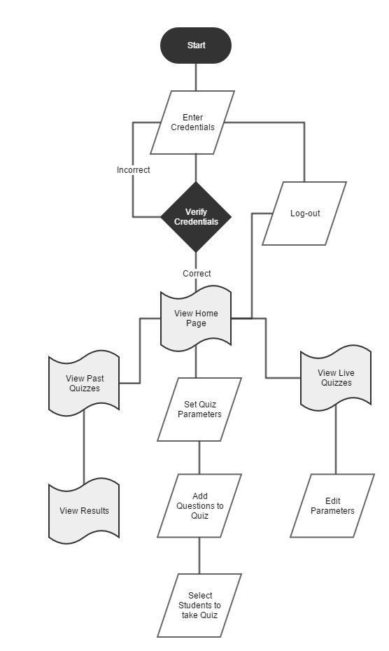

**Flow chart for Teacher**

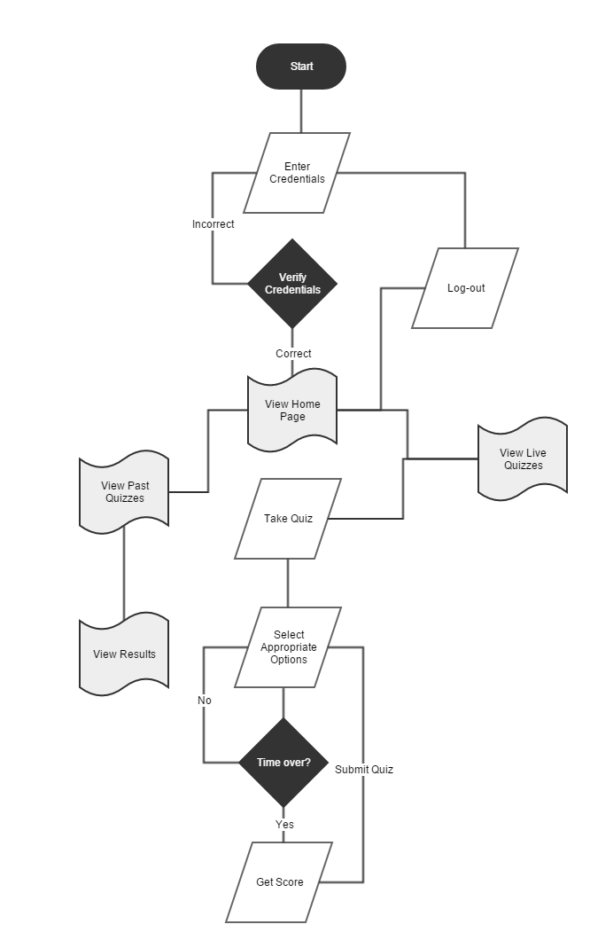

**Flow chart for Student**

**PAGE ORGANISATION:**

* class.user.php – Class to represent the user
* dbconfig.php – Database configuration info
* index.php – Landing page and also sign-up/log-in page
* home.php – Home page shown after log-in
* live.php – Shows Live Quizzes if any
* past.php – Shows Past Quizzes if any
* setQuiz.php – Form for setting quiz
* addQuestions.php – Form to add questions to quiz
* selectStudents.php – Select students to take quiz
* quiz.php – Main quiz taking page
* fpass.php – Forget password page
* verify.php – Verify new user
* resetPassword.php – Form to reset password
* qValidate.php – Validate quiz link
* userAnswers.php – Processes and stores student’s answers

**WEB TECHNOLOGIES USED:**

* Front end: HTML, CSS, JavaScript, Bootstrap.
* Back end: PHP, MySQL, AJAX, JSON.
* Server hosting: XAMPP local host server.

**EXTERNAL LIBRARY DEPENDENCIES:**

* JQuery – For enhanced JavaScript functionalities
* Lobibox – For pop-up messages
* Datatables – For adding functionalities to HTML tables
* Datetimepicker – For selecting dates
* Mailer – PHP library to send mails via SMTP

**2.3 HARDWARE AND SOFTWARE REQUIREMENTS**

**HARDWARE REQUIREMENTS:**

* Computer Network (Intranet or Internet)
* System with at least dual core processor and 2 GB RAM.

**SOFTWARE REQUIREMENTS:**

* JavaScript enabled web browsers (Chrome, Safari, Firefox, IE, etc.)
* MySQL server 5.6 and above.
* Operating System Support: Windows, Linux and Mac OS.

**2.4 SCREENSHOTS**

**CONCLUSION AND FUTURE ENHANCEMENT**

The website developed is a basic implementation of an “Online Quiz” and can be extended and enhanced for better efficiency and functionality. The following features can be added to the system:

* Creation of student groups for easy selection of students for taking the quiz.
* Question bank can be maintained so that questions can be randomly selected and given from there. But this involves the one-time effort of entering many questions.
* Stricter measures to prevent cheating.

**BIBLIOGRAPHY**

**WEBSITES:**

* <http://www.w3schools.com>
* <http://msdn.tutorialpoint.com>
* <http://www.stackoverflow.com>

**BOOKS:**

* Programming the World Wide Web by Robert W. Sebesta
* Pro HTML5 and CSS3 Design Patterns by Er.V.K.Jain